Hamza 24k-3065
Q1
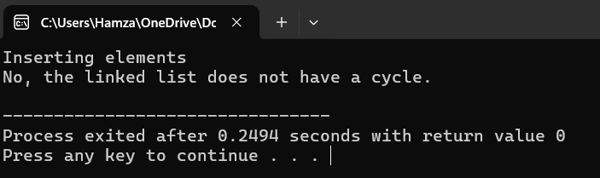
#include <iostream>
using namespace std;

class Node {
public:
int data;
Node* next;

Node(int value) {
data=value;
next=NULL;
}
};

class SinglyLinkedList {
private:
Node* head;

public:
SinglyLinkedList() {
head=NULL;
}

void insertAtEnd(int value) {
Node* newNode=new Node(value);

if (head==NULL) {
head=newNode;
} else {
Node* temp=head;
while(temp->next!=NULL) {
temp=temp->next;
}
temp->next=newNode;
}
}

void display() {
if (head==NULL) {
cout<<"List is empty."<<endl;
return;
}
Node* temp=head;
cout<<"Linked List: ";
while (temp!=NULL) {
cout<<temp->data<<" -> ";
temp=temp->next;
}
cout<<"NULL"<<endl;
}

bool hasCycle() {
Node* fast=head;
Node* slow=head;

while (fast != NULL && fast->next != NULL) {
fast=fast->next->next;
slow=slow->next;
if (fast==slow) {
return true;
}
}
return false;
}

};

int main() {
SinglyLinkedList list;

cout <<"Inserting elements"<<endl;
list.insertAtEnd(10);
list.insertAtEnd(20);
list.insertAtEnd(30);
list.insertAtEnd(40);

if (list.hasCycle()) {
cout<<"Yes, the linked list has a cycle."<<endl;
} else {
cout<<"No, the linked list does not have a cycle."<<endl;
}

return 0;
}

Q2
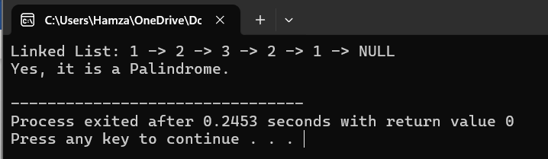
#include <iostream>
using namespace std;

class Node {
public:
int data;
Node* next;

Node(int value) {
data=value;
next=NULL;
}
};

class SinglyLinkedList {
private:
Node* head;

public:
SinglyLinkedList() {
head=NULL;
}

void insertAtEnd(int value) {
Node* newNode=new Node(value);

if (head==NULL) {
head=newNode;
} else {
Node* temp=head;
while(temp->next!=NULL) {
temp=temp->next;
}
temp->next=newNode;
}
}

void display() {
if (head==NULL) {
cout<<"List is empty."<<endl;
return;
}
Node* temp=head;
cout<<"Linked List: ";
while (temp!=NULL) {
cout<<temp->data<<" -> ";
temp=temp->next;
}
cout<<"NULL"<<endl;
}
bool Ispalandrome() {
Node* slow=head;
Node* fast=head;
while(fast->next!=NULL && fast->next->next!=NULL){
fast=fast->next->next;
slow=slow->next;
}
Node* curr=slow->next;
Node* prev=NULL;
Node* newNode=NULL;
while(curr!=NULL){
newNode=curr->next;
curr->next=prev;
prev=curr;
curr=newNode;
}
Node* h=head;
Node* rev=prev;
while(rev!=NULL){
if(h->data!=rev->data){
return false;
}
h=h->next;
rev=rev->next;
}
return true;
}

};

int main() {
SinglyLinkedList list;

list.insertAtEnd(1);
list.insertAtEnd(2);
list.insertAtEnd(3);
list.insertAtEnd(2);
list.insertAtEnd(1);

list.display();

if (list.Ispalandrome()) {
cout << "Yes, it is a Palindrome." << endl;
} else {
cout << "No, it is not a Palindrome." << endl;
}

return 0;
}
Q3
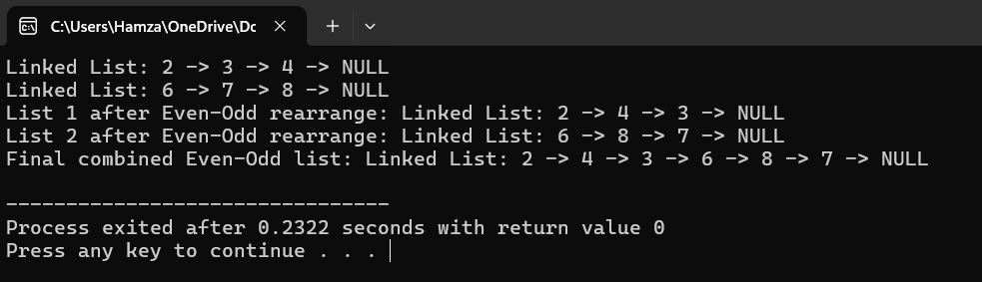
#include <iostream>
using namespace std;

class Node {
public:
int data;
Node* next;

Node(int value) {
data=value;
next=NULL;
}
};

class SinglyLinkedList {
private:
Node* head;

public:
SinglyLinkedList() {
head=NULL;
}

void insertAtEnd(int value) {
Node* newNode=new Node(value);

if (head==NULL) {
head=newNode;
} else {
Node* temp=head;
while(temp->next!=NULL) {
temp=temp->next;
}
temp->next=newNode;
}
}

void display() {
if (head==NULL) {
cout<<"List is empty."<<endl;
return;
}
Node* temp=head;
cout<<"Linked List: ";
while (temp!=NULL) {
cout<<temp->data<<" -> ";
temp=temp->next;
}
cout<<"NULL"<<endl;
}

void EvenOddCheck() {
Node* evenh=NULL;
Node* eventail=NULL;
Node* oddh=NULL;
Node* oddtail=NULL;
Node* curr=head;
while(curr!=NULL){
if(curr->data%2==0){
if(evenh==NULL){
eventail=curr;
evenh=curr;
}
else{
eventail->next=curr;
eventail=curr;
}
}
else{
if(oddh==NULL){
oddh=curr;
oddtail=curr;
}
else{
oddtail->next=curr;
oddtail=curr;
}
}
curr=curr->next;
}
if(oddtail!=NULL){
oddtail->next=NULL;
}
if(eventail!=NULL){
eventail->next=oddh;
}

}

void concatenate(SinglyLinkedList &other) {
if (head==NULL){
head=other.head;
return;
}
Node* temp=head;
while(temp->next!=NULL){
temp = temp->next;
}
temp->next=other.head;
return;
}

};

int main() {
SinglyLinkedList list1, list2;
list1.insertAtEnd(2);
list1.insertAtEnd(3);
list1.insertAtEnd(4);
list1.display();

list2.insertAtEnd(6);
list2.insertAtEnd(7);
list2.insertAtEnd(8);
list2.display();

list1.EvenOddCheck();
list2.EvenOddCheck();

cout << "List 1 after Even-Odd rearrange: ";
list1.display();

cout << "List 2 after Even-Odd rearrange: ";
list2.display();

list1.concatenate(list2);

cout << "Final combined Even-Odd list: ";
list1.display();

return 0;
}
Q4
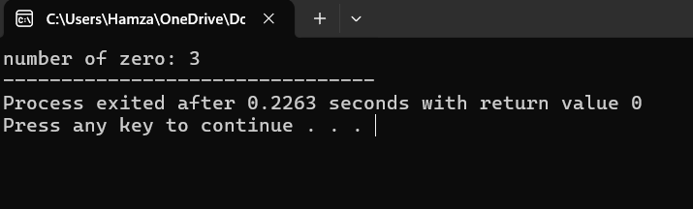
#include<iostream>
using namespace std;

int countzero(int n){
if(n==0)
{
return 0;
}
int lastdigit=n%10;
if(lastdigit==0){
return 1+countzero(n/10);
}
else{
return countzero(n/10);
}
}

int main(){
int n=1020304;
int p=countzero(n);

cout<<"number of zero: "<<p;
return 0;

}
Q5
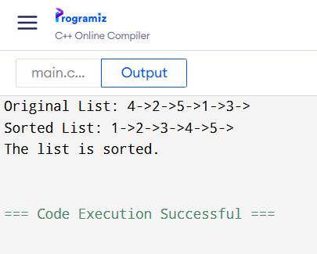
#include <iostream>
using namespace std;

class Node {
public:
int data;
Node* next;
Node(int val) {
data = val;
next = NULL;
}
};

Node* mergeSortedLists(Node* a, Node* b) {
if (!a){
return b;}
if (!b){
return a;}

if (a->data<b->data) {
a->next = mergeSortedLists(a->next, b);
return a;
} else {
b->next = mergeSortedLists(a, b->next);
return b;
}
}

void splitList(Node* head, Node** firstHalf, Node** secondHalf) {
if (!head || !head->next) {
*firstHalf = head;
*secondHalf = NULL;
return;
}

Node* slow=head;
Node* fast=head->next;

while (fast&&fast->next) {
slow = slow->next;
fast = fast->next->next;
}

*firstHalf=head;
*secondHalf=slow->next;
slow->next=NULL;
}

Node* sortLinkedList(Node* head) {
if (!head || !head->next){
return head;
}

Node* firstHalf;
Node* secondHalf;

splitList(head, &firstHalf, &secondHalf);

firstHalf=sortLinkedList(firstHalf);
secondHalf=sortLinkedList(secondHalf);

return mergeSortedLists(firstHalf, secondHalf);
}

bool isSorted(Node* head) {
while (head && head->next) {
if (head->data>head->next->data) {
return false;
}
head = head->next;
}
return true;
}

void printList(Node* head) {
while (head) {
cout<<head->data << "->";
head=head->next;
}
cout<<endl;
}

int main() {
Node* head = new Node(4);
head->next = new Node(2);
head->next->next = new Node(5);
head->next->next->next = new Node(1);
head->next->next->next->next = new Node(3);

cout<<"Original List: ";
printList(head);

head=sortLinkedList(head);

cout<<"Sorted List: ";
printList(head);

if(isSorted(head))
cout<<"The list is sorted."<<endl;
else
cout<<"The list is NOT sorted."<<endl;
return 0;
}
Q6
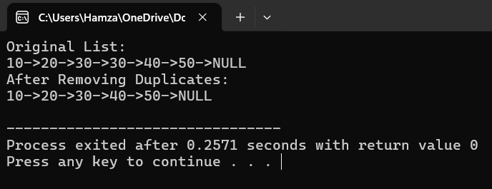
#include<iostream>
using namespace std;

class Node{
public:
Node* next;
int data;
Node(){
data=0;
next=NULL;
}
Node(int value){
data=value;
next=NULL;
}
};
Node* head=NULL;
void InsertByvalue(int value){

Node* newNode=new Node(value);
newNode->next=head;
head=newNode;
}

Node* deleteDup(Node* head){
if(head==NULL || head->next==NULL){
return head;
}
head->next=deleteDup(head->next);
if(head->data==head->next->data){
Node* temp=head->next;
delete head;
return temp;
}
return head;
}
void display(){
Node* temp=head;
while(temp!=NULL){
cout<<temp->data<<"->";
temp=temp->next;
}
cout<<"NULL"<<endl;
}
int main(){

InsertByvalue(50);
InsertByvalue(40);
InsertByvalue(30);
InsertByvalue(30);
InsertByvalue(20);
InsertByvalue(10);

cout << "Original List: "<<endl;
display();

head=deleteDup(head);

cout << "After Removing Duplicates: "<<endl;
display();
return 0;

}
Q7
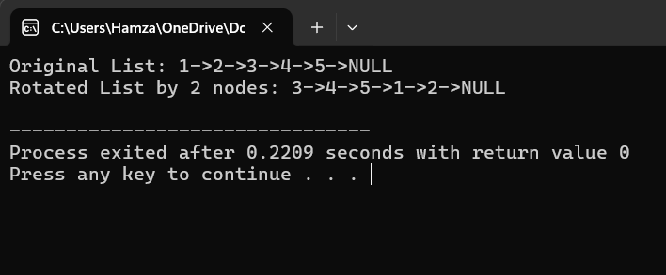
#include<iostream>]
using namespace std;
class Node{
public:
Node* next;
int data;
Node(){
data=0;
next=NULL;
}
Node(int value){
data=value;
next=NULL;
}
};
Node* rotate(Node* head,int k){
if(head==NULL || head->next==NULL || k==0){
return head;
}
Node* newhead=head->next;
Node* temp=head;

Node* tail=newhead;
while(tail->next!=NULL){
tail=tail->next;
}
tail->next=head;
head->next=NULL;
return rotate(newhead,k-1);
}
void display(Node* head){
Node* temp=head;
while(temp!=NULL){
cout<<temp->data<<"->";
temp=temp->next;
}
cout<<"NULL"<<endl;
}
int main() {
Node* head = new Node(1);
head->next = new Node(2);
head->next->next = new Node(3);
head->next->next->next = new Node(4);
head->next->next->next->next = new Node(5);

int k = 2;
cout << "Original List: ";
display(head);

head = rotate(head, k);

cout << "Rotated List by " << k << " nodes: ";
display(head);

return 0;
}

Q8
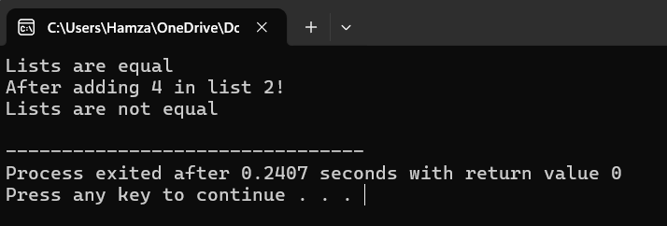
#include<iostream>]
using namespace std;
class Node{
public:
Node* next;
int data;
Node(){
data=0;
next=NULL;
}
Node(int value){
data=value;
next=NULL;
}
};

bool compareList(Node* head1,Node* head2){
if(head1==NULL && head2==NULL){
return true;
}
if(head1==NULL || head2==NULL){
return false;
}
if(head1->data != head2->data){
return false;
}
return compareList(head1->next,head2->next);
}
int main() {
Node* head1 = new Node(1);
head1->next = new Node(2);
head1->next->next = new Node(3);

Node* head2 = new Node(1);
head2->next = new Node(2);
head2->next->next = new Node(3);

if (compareList(head1, head2)){
cout<<"Lists are equal"<<endl;
}
else{
cout<<"Lists are not equal"<<endl;
}
head2->next->next->data=4;
cout<<"After adding 4 in list 2!"<<endl;

if (compareList(head1,head2)){
cout<<"Lists are equal"<<endl;}
else{
cout<<"Lists are not equal"<<endl;
}
return 0;
}

Q9
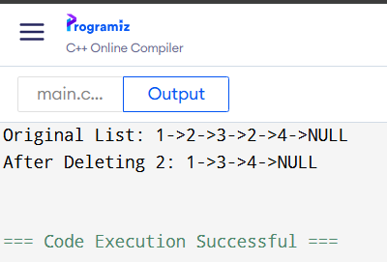
#include<iostream>
using namespace std;
class Node{
public:
Node* next;
int data;
Node(){
data=0;
next=NULL;
}
Node(int value){
data=value;
next=NULL;
}
};
void display(Node* head){
Node* temp=head;
while(temp!=NULL){
cout<<temp->data<<"->";
temp=temp->next;
}
cout<<"NULL"<<endl;
}
Node* deleteNode(Node* head,int val){
if(head==NULL){
return NULL;
}
head->next=deleteNode(head->next,val);

if(head->data==val){
Node* temp=head;
head=head->next;
delete temp;
}
return head;
}
int main() {
Node* head = new Node(1);
head->next = new Node(2);
head->next->next =new Node(3);
head->next->next->next = new Node(2);
head->next->next->next->next = new Node(4);

cout<<"Original List: ";
display(head);

int val=2;
head =deleteNode(head,val);

cout<<"After Deleting "<<val<<": ";
display(head);

return 0;
}
Q10
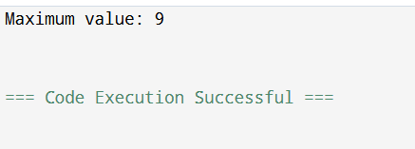
#include<iostream>
#include <climits>,,to get INT_MIN constant
using namespace std;
class Node{
public:
Node* next;
int data;
Node(){
data=0;
next=NULL;
}
Node(int value){
data=value;
next=NULL;
}
};
int max_value(Node* head){
if(head==NULL){
return INT_MIN;
}
int restmax=max_value(head->next);
if(head->data>restmax){
return head->data;
}
else{
return restmax;
}
}
void display(Node* head){
Node* temp=head;
while(temp!=NULL){
cout<<temp->data<<"->";
temp=temp->next;
}
cout<<"NULL"<<endl;
}
int main() {
Node* head = new Node(3);
head->next = new Node(7);
head->next->next = new Node(2);
head->next->next->next = new Node(9);

cout << "Maximum value: " << max_value(head) << endl;

return 0;
}

